#OpioidCrisis Pain Related SUICIDES associated with forced tapers
May 30, 2018 More PAIN RELATED SUICIDES added associated with opioid pain medication reductions and discontinuations as recommended by the CDC and by Andrew Kolodny, M.D. and his “Physicians for Responsible Opiate Prescribing” (PROP)
Phillip Kuykendall from Statesville, North Carolina was a 63 year old man, an active member of society and hobbyist whose doctor refused to prescribe medication for his pain disease. After a stay in a hospital near Statesville where he went to have his pain disease assessed, he was discharged with no pain medicine. His brother, who was involved with helping him obtain pain control, went to Phillip’s home on December 29, 2016 and found Phillip dead with a self-inflicted gunshot wound in his head. “He took the last, and only, relief he thought he had left,” said a person familiar with the situation.
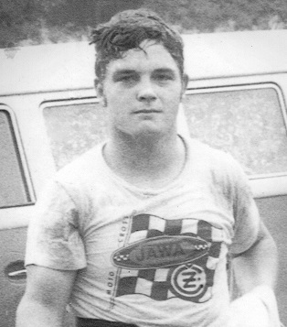

Mercedes McGuire of Indiana ended her life August 4th, 2017 after struggling with agony originally suppressed with opioid pain medicine but reappearing after her pain medicine was cut back in a fashion after the CDC regulations. She was in such discomfort she went to the ER because she could not stand the intractable pain by “learning to live with it” as suggested by CDC consultants. The ER gave her a small prescription. She went to the pharmacy where they refused to fill it “because she had a pain contract.” She went home and killed herself. She was a young mother with a 4 year old son, Bentley.
Allison Kimberly, age 30, of Colorado was denied treatment for her intractable pain from interstitial cystitis and several other painful conditions. Interstitial cystitis can end in suicide from the failure to treat it properly as it is an extreme form of agonizing discomfort. It is said that the University of Colorado emergency room in Aurora refused her treatment for her pain.
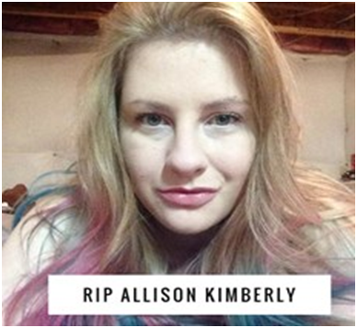
deceased
Allison posted on Instagram describing how she was treated as an addict and sent away without pain medicine. “I was rushed to the ER because my pain was so out of control I couldn’t take it anymore, I got ZERO help. After 7 hours I was discharged. The nurse has the nerve to say that my kind of pain shouldn’t be that bad and basically I was faking for medication. I am so beside myself I am shaking as I type this. Screaming and begging in pain, needing any kind of help they’d give me and I was just sent home. As soon as I am able I’m reporting my whole experience.” Allison did not have time to file a complaint against the hospital as she violently ended her life while her mother walked her dog, the animal companion that had made her anguish less lonely. No doctors appear to have been charged. The Colorado Hospital Association was in the process of piloting a no-opioid policy for the state. She died in June, 2017.
Jessica was a “pain warrior”, loved by a group of people with similar issues dealing with intractable pain after forcibly reducing her pain medicines as suggested by the contagious disease specialists at CDC encouraging doctors to reduce “opioids” for fear people might addict or die from an overdose. Jessica had particularly painful central pain syndrome that is untreatable except for pain suppression. She would never have addicted as she was already on pain medicine. She ended her life after inadequate treatment by physicians (other details withheld).

Ryan J. Trunzo
- Ryan Trunzo of Massachusetts committed suicide at the age of 26. He was an army veteran of Iraq. He had experienced fractures in his back for which he tried to get effective painkillers, but failed because of the VA’s policy of denying or reducing needed pain medication. His mother stated: “I feel like the VA took my son’s life.”

.Kevin Keller, a Navy veteran from the USS Independence in the 1980’s was from Virginia. He took his own life at age 52. He shot himself after breaking into the house of his friend, Marty Austin, to take his gun. Austin found a letter left by Keller saying “Marty sorry I broke into your house and took your gun to end the pain!” Keller had experienced a stroke 11 years earlier, and he had worsening pain in the last two years of his life because VA doctors would not give him pain medicine. On the subject of pain medication, Austin said that Keller “was not addicted. He needed it.” The suicide occurred one year after the VA announced the “Opioid Safety Initiative” to stop pain medicines for US veterans, like Kevin Keller. The VA would not comment. http://www.roanoke.com/news/virginia/veteran-s-suicide-draws-attention-to-veterans-affairs-use-of/article_a07a3527-0f33-5cca-9cb5-a5d198b8f193.html

Donald Alan Beyer, living in Idaho, had experienced back pain for years. He suffered from a job-related injury resulting in a broken back. After his doctor retired, Beyer struggled without pain medicine for months. He tried his best using other methods, nothing worked except the opiate pain medicine he had been taking long term. . He shot himself on his 47th birthday. His son said he before his death he could not get out of bed to make it to the bathroom. He was a logger and the painkillers allowed him to function. Physicians refused treat him. He had two small grandsons. No doctors were charged as complicit.

Bob Mason, age 67 of Helena, Montana was denied pain medicine to treat his chronic pain after losing access to his pain control doctor and finding no one else, took his own life in January of 2016. He tried to “deal with his pain” as is recommended by the new pain minimizer CDC consultants. He tried for 7 days to deal with it.
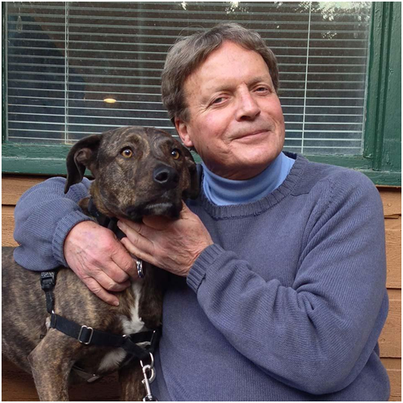
Bob Mason
According to Mason’s daughter, Mieska, the last couple weeks up before Bob passed away, there were a lot of tears everyday on the phone,” she said, “between the pain and really just the sadness of not being able to walk his dog, but, I’m sure it was more than that. There would be tears, then he would joke,” she said, “then he’d call back an hour later and be teary and in pain again. He didn’t like the drugs, but there were no other options.” His suicide became the other option.

Zach Williams of Minnesota died by his own hand at age 35. He was an army veteran of Iraq and had experienced back pain and a brain injury in battle. He had successfully treated his pain with opiate pain medicine until the VA began reducing prescriptions under the new VA law, December 2015, based on CDC recommendations of reducing or stopping pain medicine to avoid addiction. Zachariah J. Williams ‘Zach’ age 35 of Apple Valley, passed away unexpectedly on September 20, 2013. Zach served his country in the US Army during the Iraq War as a SSG in the infantry, were he earned a; Campaign Medal with three Stars, Bronze Star, two Purple Hearts and numerous other medals and awards. He is preceded in death by his grandparents, Delard & Gloria Carmichael and Gerald Williams. Survived by his children, Zachariah Jr. and Hallie Williams and their mother, Charlene, also by his mother, Kathy Williams; father, Darl (Nancy) Williams; siblings, Zana (Mark) Niles and Zaaron Williams; and Zach’s significant other, Neva Howard and her son, Elijah and Zach and Neva’s unborn baby girl, Katerina; grandmother, Dorthea Williams.

A Cleveland, Ohio resident (name withheld), mother of a teenage daughter, and wife was denied her long term pain medicine reportedly by doctors at the Cleveland Clinic. She had a spinal electrical stimulator implanted, at great cost and discomfort in order to satisfy CDC’s dictum of “alternative” treatment first even if more expensive, painful and less effective. It did little to help. What worked was long term opiate medicine which was successful in the past without side effects or addiction. Her medicine was reduced for no other reason other than honoring CDC “voluntary” directives. She waited for her husband to be out of town and her daughter to with a friend, then took her life to stop the intractable pain in August of 2016.

In Waldport, a small town in coastal Oregon, Sonja Mae Jonsson, 42, previously vigorous camper and hiker in the Oregon mountains sustained a traumatic brain injury in 2006 leaving her with pain she describe as an “axe in the back of my head”, She was controlled with pain medication. She was cut off from her pain medicines according to CDC negative portrayal of opioid pain medicine. After her pain medicine was stopped without her permission she had a return of around the clock intractable pain levels previously lessened with opiates. Her now untreated pain was so severe that “even though I don’t want to end my life”, she did — recently. http://www.bendbulletin.com/localstate/5356986-151/police-consider-charging-mother-in-bend-suicide
Denny Peck of Washington State was 58 when he ended his life. In 1990, he experienced a severe injury to his vertebrae during a boating accident. His mother, Lorraine Peck, said “he had been in severe pain ever since,” and his daughter, Amanda Peck, said she didn’t remember a time when her dad didn’t hurt. During the last few years of his life, Peck had received opiates for his pain from a Seattle Pain Center, until these clinics closed after DEA raids. Seattle, the University of Washington Pain Doctors, the State nor the Federal Government and the DEA made provision for the continuation of care for the estimated 12,000 patients. After suffering and unable to find doctors who would help with his pain, Peck called 911. Becoming a pariah, like many other former patients of any DEA closed clinic, Denny could find no one to continue the previously successful pain treatment. Two days after asking for help at the ER and not getting any, Peck was found dead in his home from a handgun. A note found near Peck read: “Can’t sleep, can’t eat, and can’t do anything. And all the whitecoats don’t care at all.” https://www.seattletimes.com/seattle-news/health/the-whitecoats-dont-care-one-mans-desperation-and-death-when-pain-clinics-close/
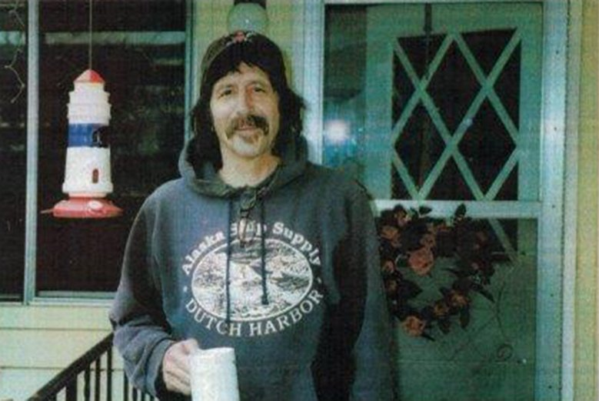

Doug Hale of Vermont killed himself at the age of 53. He had experienced pain from interstitial cystitis, and decided to end his life six weeks after his doctor suddenly cut off his opiate painkillers. He left a note reading “Can’t take the chronic pain anymore” before he shot himself. His doctor said he was no longer willing to risk his license by writing him another “script for Opioids”.
Doug Hale, wife and daughter
Mrs. Hale can be contacted and is going public with her husband’s suicide as a direct result of forcibly without consent, refusing effective pain treatment. His widow feels long term pain patients like Doug are examples of horrible decisions people have to make weighing the options of not being able to function or “resting in peace” all for the fear pain medicines will cause addiction. Doug was not addicted so it made no sense to stop his life giving pain disease medicine, according to Ms. Hale. Doug left his daughter Nicole, 5 younger siblings and their children plus an ‘honorary’ 4 year old grandchild who is still looking for “Grampy”. Doug waited until his family was away so they would not have to watch and relieved his untreated pain with a handgun on 10–10–16. http://www.slate.com/articles/health_and_science/medical_examiner/2017/08/cutting_down_on_opioids_has_made_life_miserable_for_chronic_pain_patients.html
Travis Patterson, a Texan, a decorated Staff Sergeant in the Army, combat veteran of Iraq and Afghanistan, was injured by a road side mine, and discharged from the army in 2016. He was in daily severe pain. He could not get pain treatment, and tried to commit suicide and was admitted to a Topeka Kansas VA hospital by his 26 year old wife. The VA refused to treat his war wounds with pain medicine and offered instead a stress ball. Two days later he made sure of his own method for treating his intractable pain by killing himself. He had a future with his wife and studying law but it did not matter. He showed no signs of mental illness, just the stress of failure to treat his underlying war injuries with long term daily pain. One other veteran remarked the US Government was finding other ways to “kill us”. http://cjonline.com/news/local/2017-02-20/wife-veteran-says-topeka-va-didn-t-do-enough-help-suicidal-husband
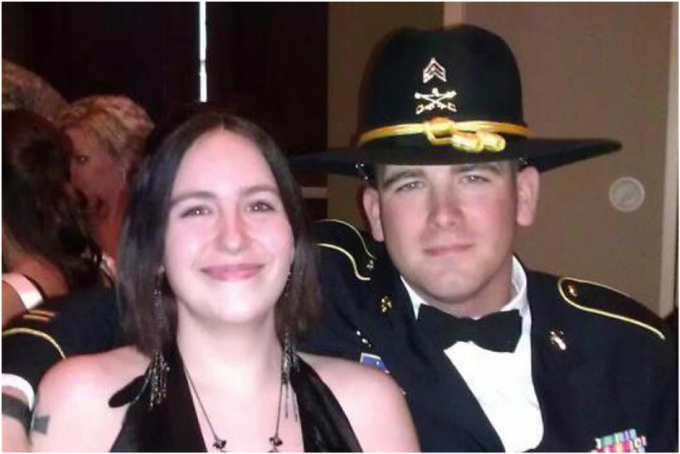
Additional information: Travis was denied pain medication for this combat wounds by the VA by law passed without knowledge of most 12–15, deep in a 2000 page budget bill. It is now federal law to forcibly taper wounded veterans with intractable pain to “prevent addiction and heroin overdoses” Travis was a Texas native).
United States veterans have been committing suicide after being unable to receive medicine for pain. These veterans include Peter Kaisen and Daniel Somers according to a reliable ex-naval medical officer. Their cases are being investigated but their records are on file with DoD/VA.
54-year-old Bryan Spece of Montana killed himself two weeks after he experienced a major reduction in his pain medication. The CDC recommends a slow reduction in pain medicine, such as a 10% decrease per week, but it was not followed. There was no medical reason to stop the medicine as it was working well. Based on information from his relative, his dose was quickly and severely reduced without his permission, “forcibly if necessary” as one CDC team member later recommended. He died over a concern of addiction which had not happened. His relative felt he should have not been reduced at all as no medical reason was given by the doctor. https://www.painnewsnetwork.org/stories/2017/5/26/patient-suicide-blamed-on-montana-pain-clinic

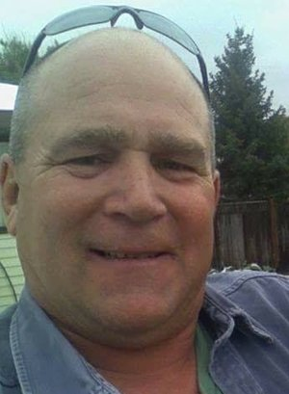

Sherri Little was 53 when she committed suicide. She was a Californian and requested her story be told. She related how she had lost her adult friendships, as many do, with her constant painful diseases: occipital neuralgia and Fibromyalgia. A friend described Little as having a “shining soul of activism” as she spent time advocating for other chronic pain sufferers. However, Little had other struggles in her life, such as her feeling that her pain kept her from forming meaningful relationships. In her final days, Little she tried to get medical help from a hospital. When she was unable to receive pain medicine Little ended her life in July of 2016. https://www.painnewsnetwork.org/stories/2016/7/4/pain-warrior-the-life-death-of-sherri-little
Former NASCAR driver Dick Trickle of North Carolina shot himself at age 71. He suffered from long-term pain. Although he went through several medical tests to determine the cause of his pain, the results could not provide relief. After Trickle’s suicide, his brother stated that Dick “must have just decided the pain was too high, because he would have never done it for any other reason.” http://www.espn.com/racing/nascar/cup/story/_/id/9286940/dick-trickle-suicide-was-caused-severe-chest-pain-brother-says

In August 2017, a couple planned a mutual suicide by carbon monoxide poisoning after being cut off from both their pain medicines in Flagler County. Florida. Katherine Goddard died after being found by her daughter. Her boyfriend, Bruce Haughton was found in the same car with his now deceased girlfriend. Haughton was barely alive. He was arrested for assisting in a suicide, and held without bond. The Flagler County Sheriff said assisting in a suicide was illegal. Doctors whom refused treatment both people apparently have not been charged or sanctioned. http://nypost.com/2017/08/17/man-busted-in-girlfriends-death-after-surviving-alleged-suicide-pact/

A 40 year old woman E.C. from Visalia, California had lupus and painful joints to the point of “barely being able to stand”. She could only go to urgent care centers since she had no health coverage. They only would provide the lowest dose pain medicine. She pulled away from her friends after suffering on inadequate doses of pain medicine. She had talked about “quitting her life” as a solution. She knew she would never have a husband since the pain immobilized her all day. She had no children and lived with her parents who did not believe in her intractable pain. Without pain relief she was trapped. Finally one day, alone, “She left. She just left,” in the words of her friend.
A 58 year old navy veteran, Jay Lawrence of Tennessee had chronic pain following an accident, a common cause of intractable pain. He had surgeries, he tried epidural steroids, nerve blocks, and a spinal cord stimulator as “alternative treatments” to avoid pain medicine, a plan recommended by the contagious disease specialists at CDC. These all failed leaving the opioid pain medicine as the next step which was done. But the Comprehensive Pain Management Clinic decided to reduce the dosage without medical reason apparently afraid of the DEA’s raids and CDC rules. His pain became nearly continuous with the low doses. When asked to restore the previous level of medicine his doctor at the Clinic said “my license is not worth my patient’s quality of life”.
Debra Bales, age 52, went to a motel in Petaluma, California, for three days with the intention of compassionately ending her life together. Debra suffered chronic pain and was taken off her pain medicines “some time ago”. They tried three times in motel and failed to cut off her breathing. They were working alone. The newspaper speculated she was in withdrawal. Together they ended her misery outside of the motel in a nearby tree, as she wished. Her husband was arrested. Editor: Living with constant pain is unimaginable. The love that it takes to help a spouse end their intractable pain…. Debra was a pain patient not an addict. Less than 1% of the population will develop addiction disease (4/1000) exposed to high doses of opiates, including heroin. It is genetic.

Jay was disabled to the degree that he was award SS disability status, but this made no difference in his pain treatment. His wife wrote his story on Pain News Network, describing Jay’s pain: “A bad day was awful for me to watch, and absolutely horrible for Jay to live.” In the end, as his wife, she assisted in the plan to end the pain once and for all. After his death his wife was charged under the state assisted suicide law. Meredith Lawrence is currently on probation for a reduced charge of reckless endangerment. Neither the Clinic nor the doctor has been charged. Meredith after much soul searching has decided to go public with how the government bullied Jay’s doctor into doing something unethical. https://www.painnewsnetwork.org/stories/2017/9/4/how-chronic-pain-killed-my-husband
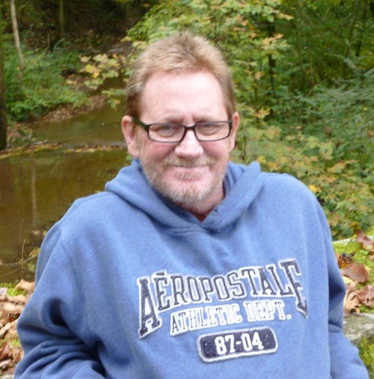
Bruce Graham, a father of three, fell from a ladder two years before his death. He broke several bones, and was in a coma for two weeks. As his relative said later in retrospect: It is unfortunate he awoke from his coma as he, for all intents and purposes, ended his life with the fall. Modern medicine was able to keep him alive through his coma, and helped with effective opiates for the recovery time in the hospital but multiple doctors were unable or unwilling to help him deal the excruciating pain every day over the next two years even with knowledge they worked well without side effects. Doctors dismissed his pain (actually post op adhesions) as psychosomatic. He was seen as an “addict” trying to “score” and treated without compassion or dignity. In January, he tried for the last time to obtain pain medicine that worked so well 18 months before. He chose to shoot himself in the chest explained to a friend weeks before. Even though a brain bullet is more “efficient” he did not want his family to “experience the trauma-inducing mess of shooting himself in the head” In January, 2017, he relieved his pain, permanently, with a gunshot wound to the heart. No prescriptions for pain medicines were found. His autopsy showed the adhesions and the spinal column disease responsible for his intractable pain. “May Bruce Graham rest in peace, but some of us will not live in peace until physicians’ attitudes and the laws change” said the teller of this story. Editor: it is common after multiple trauma to have lifelong pain emanating from various areas, and expanding into the whole body if not treated.

Kellie Bernson, a resident of Grand Junction, Colorado had a long history of multiple medical problems including a stroke and trigeminal neuralgia. Her death was reported on the many Facebook pages dealing with refused treatment for intractable pain in the United States for fear of causing addiction and “getting in trouble”. The face book report: “Kellie was a good friend to many of us in the pain community and she will be dearly missed. She has crossed over the “rainbow bridge” now. She is finally in no pain” Members of the ATIP group of advocates for pain patients tried desperately to get help for her in Colorado, but failed. She committed suicide December 10, 2016, a 59 year old widow and mother, in her home town of Grand Junction.

Michelle Bloem was a person who could not absorb pain medicines for her intractable pain from her Central Pain Syndrome triggered after trauma where pain and swelling move from the original injury site to various other areas of the body and with it pain so severe that it requires long term treatment. It is a frequent and known “suicide disease.” Dr. Forrest Tennant, the leading expert in difficult to treat pain patients, discovered her inherited inability to absorb oral pain medications, but meaning she could absorb injections of pain medicine. It worked as she said: “I experienced instant relief and received my quality of life back. I have taken this for two years with relief and no side effects”
Michelle Bloem (deceased)
The medication was not covered by her insurance and was too expensive. On January 29, 2017, Michelle Bloem killed herself. The concerns she would become addicted to her pain medicine were unfounded. She was young. She had a small son and a husband. She had no mental illness, just intractable pain.
Jennifer Adams of Helena, Montana was 41 when she ended her own life by gunshot. She was a deputy sheriff, avid athlete, and mother of an 11-year-old son. Jennifer suffered from reflex sympathetic disease and arachnoiditis both incurable diseases. Her doctor, Dr. Mark Ibsen, told her to use opioids for her pain, despite the fact that “her law enforcement background made her skeptical of opioids.” Jennifer went to the famed pain specialist Dr. Forest Tennant, “who is known as a staunch advocate of using opioids for the treatment of intractable chronic pain.” The use of opioids helped Jennifer to live with her pain and lead a normal life. Then, Dr. Tennant closed his pain clinic after raids by the DEA without charges. According to her friends, Jennifer had been living in fear that her dosage of opioid medication would be reduced. After the closure of Dr. Tennant’s clinic, Jennifer “finally determined she couldn’t take it anymore.” She was a single mom and left a 10 year son in the hands of her family. She would be alive today if pain care was provided in her area. Most patients like Jenn are reporting virtually no doctors to take their cases due to the fear of arrest and raids for providing compassionate care after the CDC declared pain medicines second line drugs and too dangerous to use for most people, a policy not based on fact according to the CDC, but based on hired consultants who worked in secret. http://nationalpainreport.com/a-montana-womans-suicide-prompts-the-question-are-we-doing-enough-8836213.html

Chris Gedney of Syracuse, New York committed suicide at age 47. Chris had been an All-American football player for Syracuse, and had joined the NFL after college. He suffered from ulcerative colitis and had many injuries during his NFL career. Chris also had surgery to remove his large intestine. A friend said that Chris had “a pain he hid from all of us.” His suicide followed a forced pain medicine reduction by a local doctor, it was reported, ulcerative colitis is an extremely painful disease with constant severe abdominal cramping. The disease has no cure, and the only treatment is to relieve pain and suffering in the truest from of compassionate medical care, palliative care. There is no law preventing physicians from prescribing full doses of opiate pain medicine in the United States and palliative care is protected from any restrictions in dosage. Friend reveals new details on Chris Gedney's death on HBO brain-injury story. https://www.syracuse.com/orangefootball/index.ssf/2018/03/chris_gedney_remembered_as_selfless_nfl_star_who_turned_setbacks_into_comebacks.html
Pam Clute of California committed suicide at the age of 66. She had been a professor of mathematics and assistant vice chancellor at UC Riverside. Pam had received several distinctions during her lifetime, including being named a Leading Woman in STEM Education. She was also known for her baking skills and for establishing a workout program. Pam was afflicted with chronic pain from a spine condition, and “medical treatment had failed to relieve the pain that shot down her legs.” Her husband was charged with assisting Pam’s suicide by supplying the gun that she used to end her life, a common response when families mutually decide life if not worth living when painful disease is not treated with compassionate pain care. In this case it appears Pam was swept up in the anti-opioid “to prevent overdose deaths” movement currently and sadly growing stronger by the day, none of which is based on fact, according to the CDC. https://www.desertsun.com/story/digital-natives/high-school/2017/12/05/steve-clute-plead-not-guilty-aiding-wifes-suicide-very-very-sad-case-attorney-says/924180001/

Doctors across the country actually believe the CDC/PROP manifesto of pain medicines not working and too dangerous to use, a false assumption. The belief that “addictions and overdoses” are being prevented by eliminating opiate pain medicine is a failure of science, reason, and common sense. These people are no longer with us due to the policy of “you are better off without pain medicines”.
No case has been reported of true addiction suddenly occurring while taking pain medicine in the 10 million with long term pain disease, belying the government’s belief that addictions will be prevented if the population as a whole does not take them.
Suicide prevention in the ten million noted by NIH requiring daily pain medicine is pain care. Not providing suicide prevention is negligence. Not treating a person in pain is negligence. Abandoning people with painful disease to the streets with no doctor, is negligence. Believing you can addict the general population is ignorance. Believing serious pain can relieved with Tylenol, meditation, expensive injection therapy, anticonvulsants, and physical therapy — is ignorant. The longer you wait to treat pain the more serious it becomes. Opiates remain the treatment of choice for serious pain, no matter what a few extremists purport.
It is difficult to tell people with constant pain to “shift their focus from pain and move on with their lives” as recommended by a founding member of “Physicians for Responsible Opioid Prescribing” (PROP) a group espousing pain denial and blanket restriction of all pain medicines, a view never before held in the history of medicine.
This nihilist medical view is not accepted by most U.S. practicing physicians, nor in other countries, nor by the World Health Organization. The CDC and its PROP consultants have an extreme view, a pain nihilism manifesto, with unfounded near shrieking polemics, a bizarre “lunatic fringe” (FDA senior official) plan for the earth riding through every doctor office in the land with warnings not to addict or kill using “heroin pills” in the words of Thomas Frieden CDC director allowing the Guideline to be published by an Agency not tasked with opiate recommendations.
The daily repetition upon repetition of this dangerous and already disproven dictum that high doses of pain medicine kill and addict is belief without evidence. Recently an ER nurse told a patent with painful obstructed pancreas, previously an indication for immediate IV morphine, she could not have any pain medicine “because of the epidemic”.
Daily media statements are sought and appear from a self-appointed “thought leader” from Brandeis University’s, Heller School, Dr. Andrew Kolodny. Dr. Kolodny is a psychiatrist and founder of PROP. We hear from no other professionals in spite of a plethora who view the “no pain treatment” manifesto with great alarm. It is the perfect “true believers” storm. No one disbelieves or is cast out and blocked.
Dr. Kolodny, has promoted himself as a self-styled thought leader for all aspects of opiates. It’s time for a balanced media view before things fall into the abyss with the horrors of forced cancelling of medical treatment at the behest of the CDC and its PROP consultants leads to enlarging this list.
Dr. Kolodny commented on the pain related suicides cases: “There is good evidence the majority were suffering from opioid addiction”. He was not familiar with the cases
— T.F. Kline MD, ed.
Thomas F. Kline, MD, PhD.
Chronic Diseases
Many opioid-dependent pain patients have a "back-up" plan in place for the day when the pain becomes unbearable. In a country where legal opioids should be both inexpensive and available to those who desperately need them, this is disgraceful!
Our government has a lot to be ashamed of, but denying pain relief to people with documented medical conditions is near the top. We're being forced to turn to illegal drugs that may be contaminated with an unknown quantity of fentanyl. The alternative is living with uncontrollable agony or turning to Dr. Ruger or the Smith and Wesson Pain Clinic. Incompetent decisions by medical professionals with no experience in treating pain have helped create this ongoing disaster.
There is NO "opioid crisis" in America. Fewer than half of the reported overdose "deaths" are actual deaths -- those numbers were culled from misleading statistics that represent the total number of drugs found in people who died in emergency facilities!! But no politician wants to be seen as soft on drugs, so they're the first to scream about the waste of human life and isn't it a shame that anyone takes those evil opioids -- ban 'em all.
What about the waste of OUR lives? Don't we matter? Do we deserve to be punished for someone else's inability to understand numbers? The DEA could give a shit less about us. They just want to hang onto their jobs, and threatening physicians who write opioid prescriptions is a lot easier than taking on well-armed drug cartels.
But condemning chronic pain patients to lives of unending suffering is an easily ignored side effect of America's mindless "war on drugs." We are collateral damage in a battle that was lost before it began.

